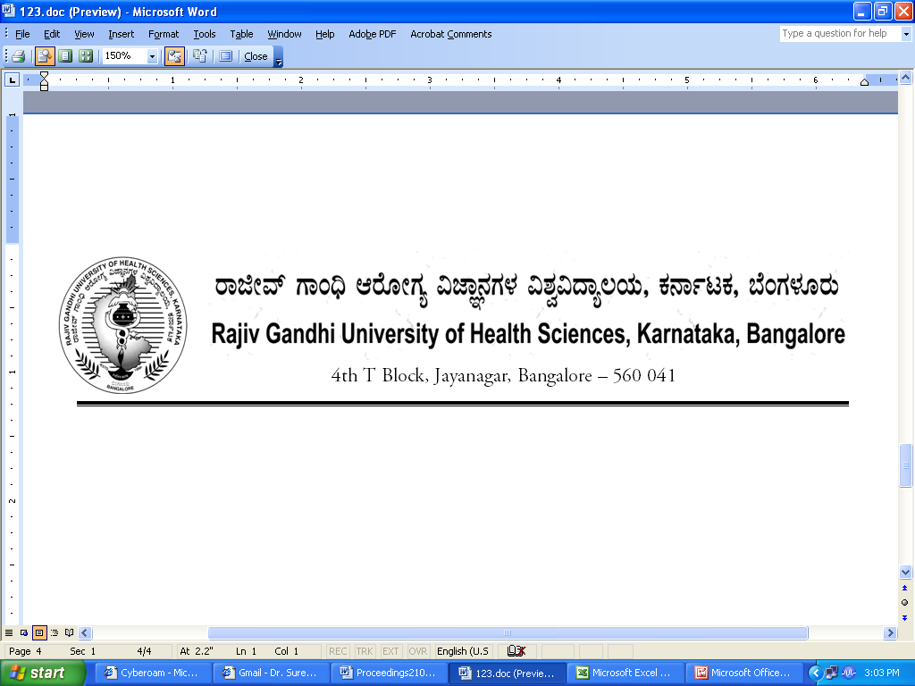
Reg(E)Exam/PG-Med/May / 2018-19/63 Date: 18/01/2018

ADVANCE NOTIFICATION

Sub: | Conduct of Post Graduate Medical & Dental Degree / Diploma Theory Examination during May/June - 2018.
********

The Post Graduate Degree / Diploma Theory Examination for the below mentioned courses will tentatively commence from 09th May – 2018 and 12th June -2018. The detailed Time Table will be notified in due courses.

 | COURSES | DATE
I | MD/MS, PG Diploma | 09th May - 2018
II | MDS and Diploma | 12th June -2018

The Principals of the concerned Colleges are requested to notify this on the Notice Board of their colleges for information of the students concerned

Sd/-

Registrar (Evaluation)
To:
All the Principals of the concerned colleges for information and needful action.

Copy to:

- PA to Vice-Chancellor/Registrar/Finance Officer, RGUHS, Bangalore.
- Deputy Registrar (Admn) section for information and needful action.
- All the officers of the RGUHS, Bangalore.
- Asst. Registrar, Regional Center, Belgaum / Gulbarga.
- Guard File.

